Education project with R: Project 1

By: Bhupendra Nirgun

Contents

1. Read the csv file : 3

2. Question 1 3

3. Question 2 5

4. Question 3 6

5. Question 4 10

6. Complete source code : 10

7. Complete console output : 10

## Read the csv file :

Read the file Project 1_Dataset.csv

## Question 1

Analyze the historical data and determine the key drivers.

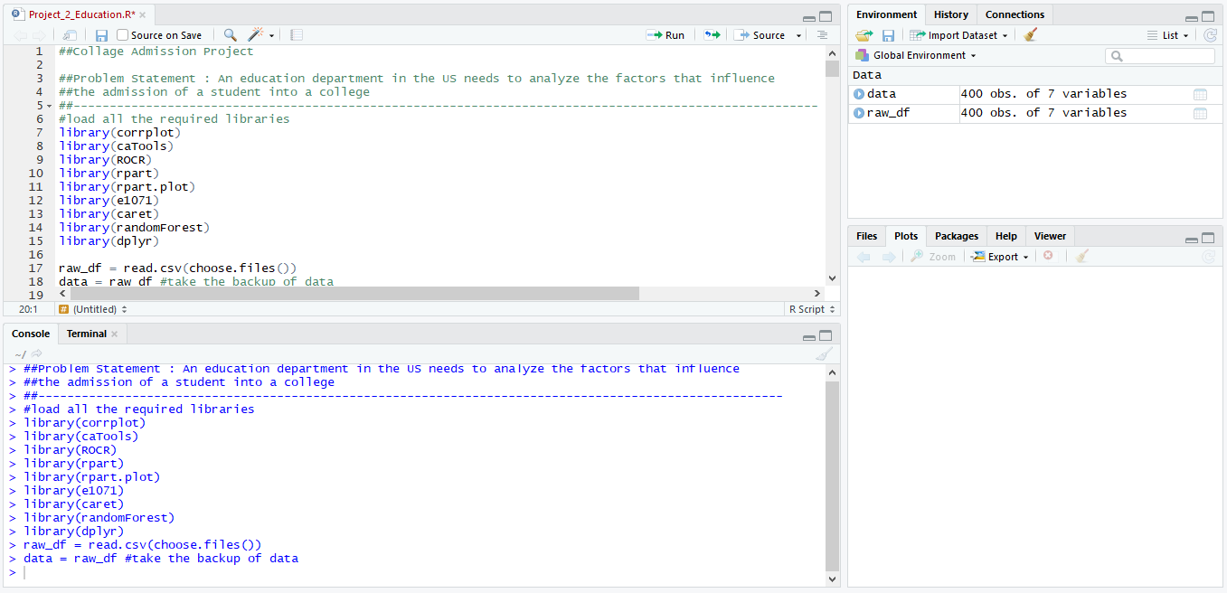

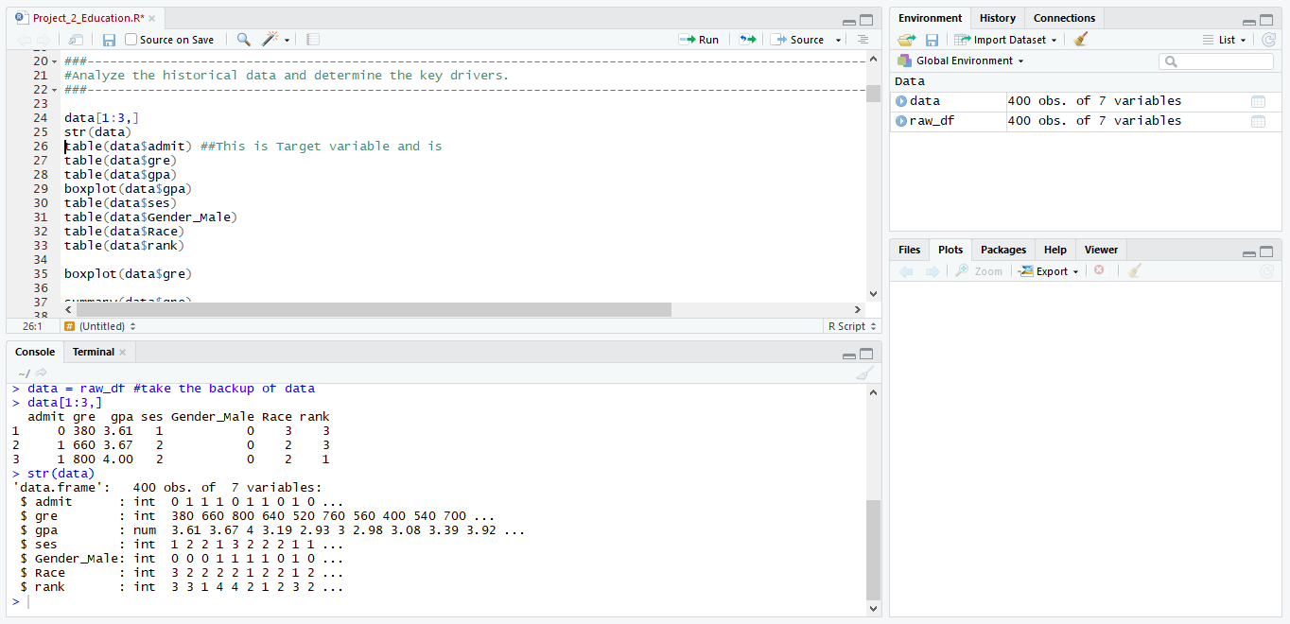

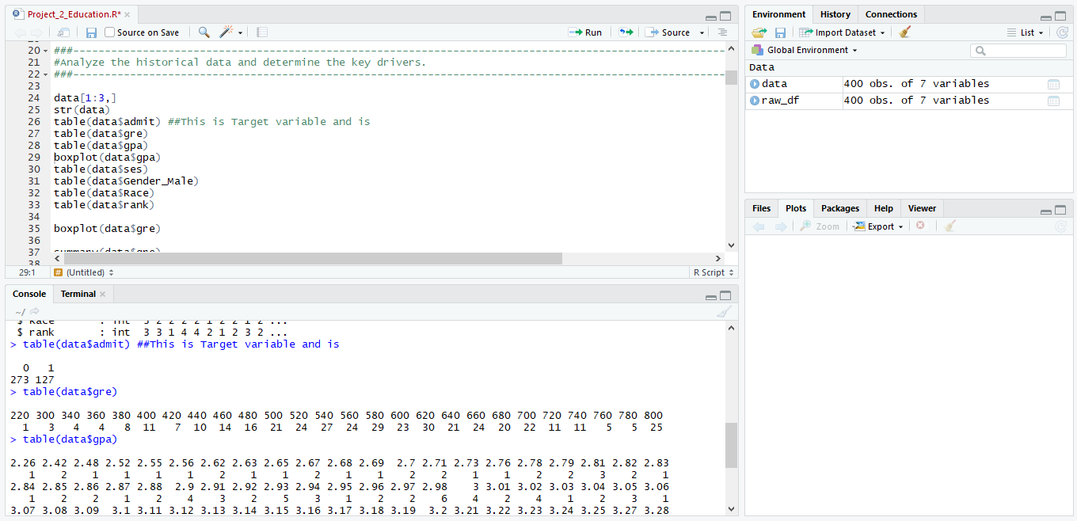

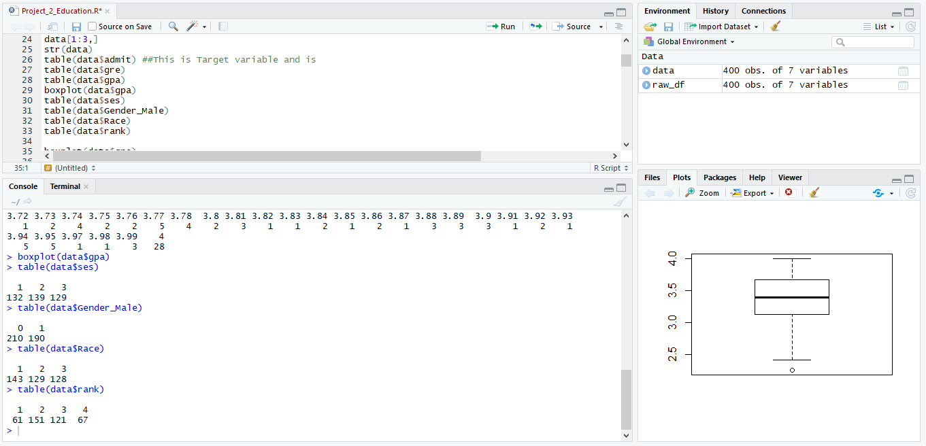

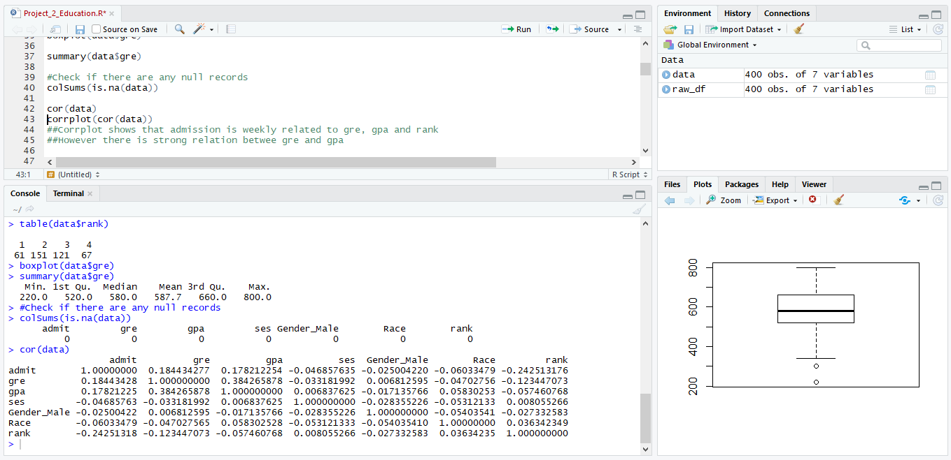

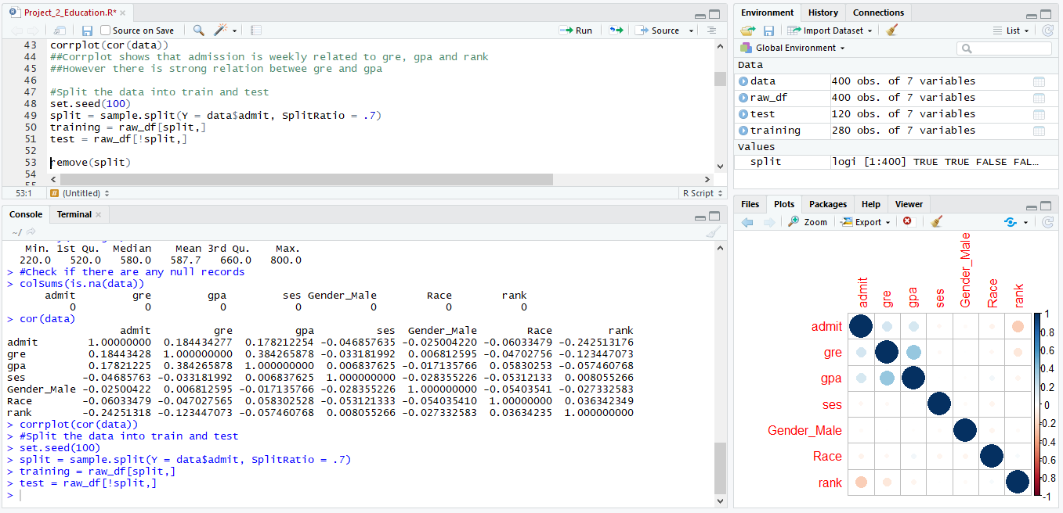

## Question 2

Run logistic model to determine the factors that influence the admission process of a student.

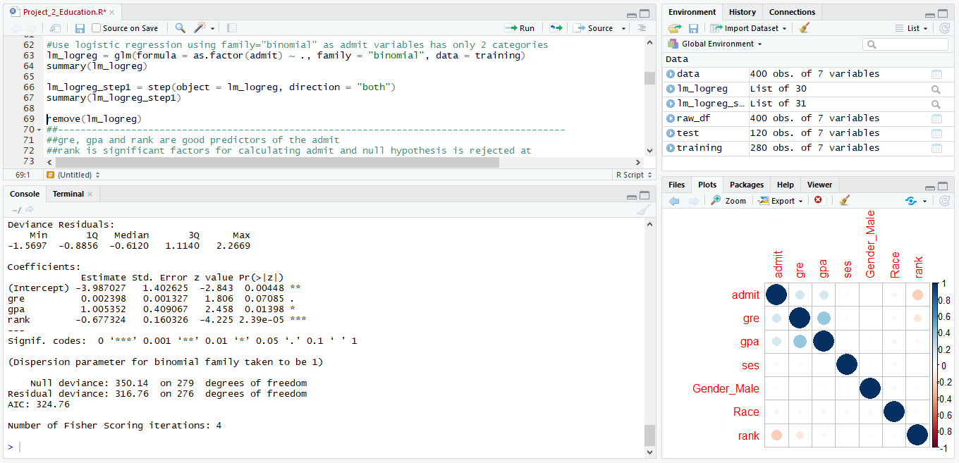

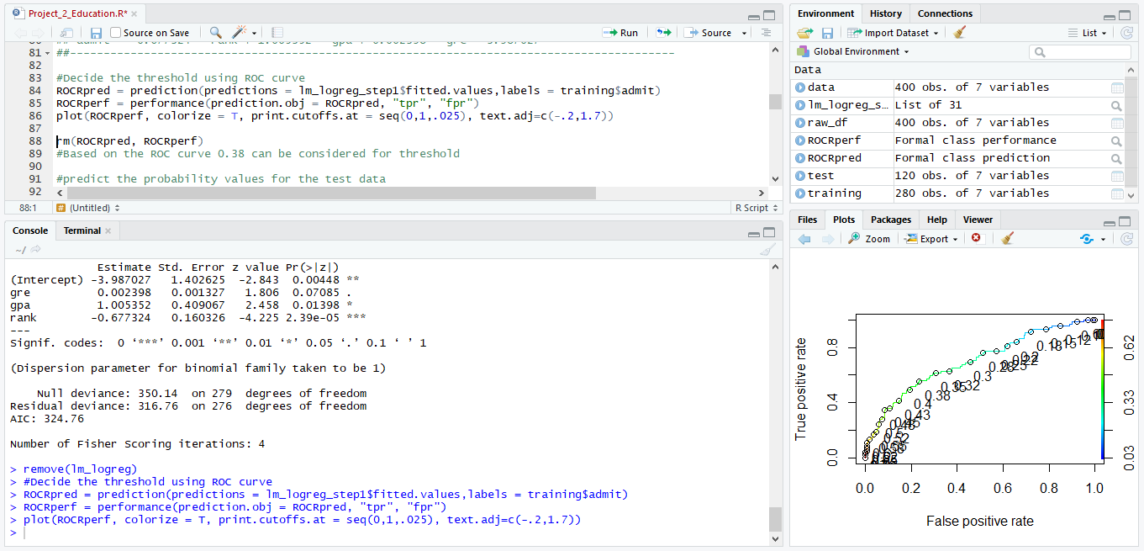

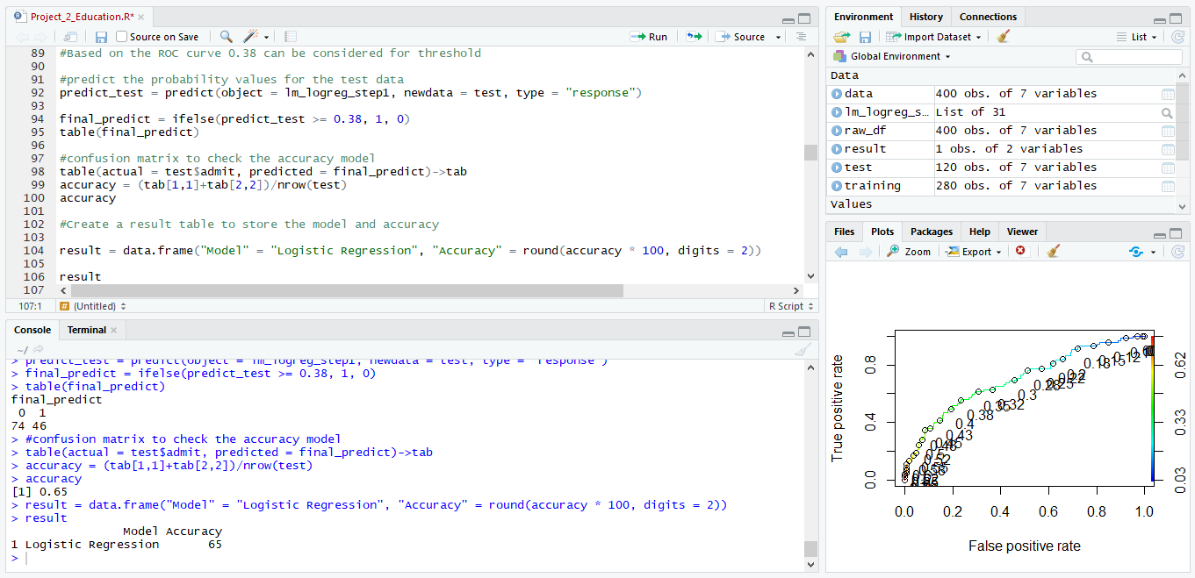

## Question 3

Try other modeling techniques like decision tree and SVM and select a champion model

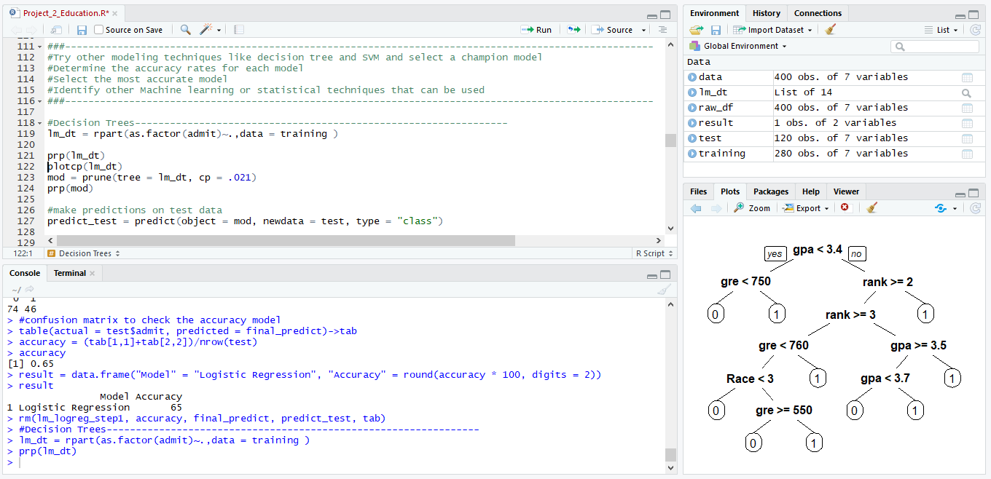

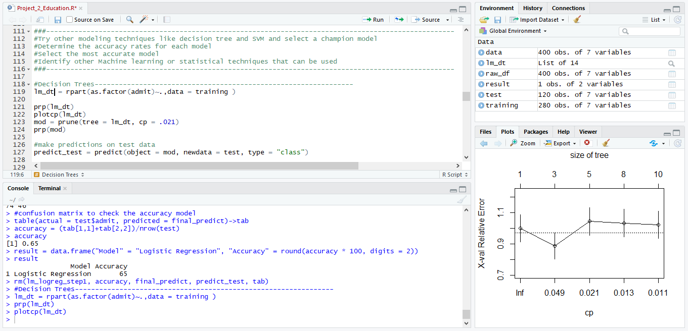

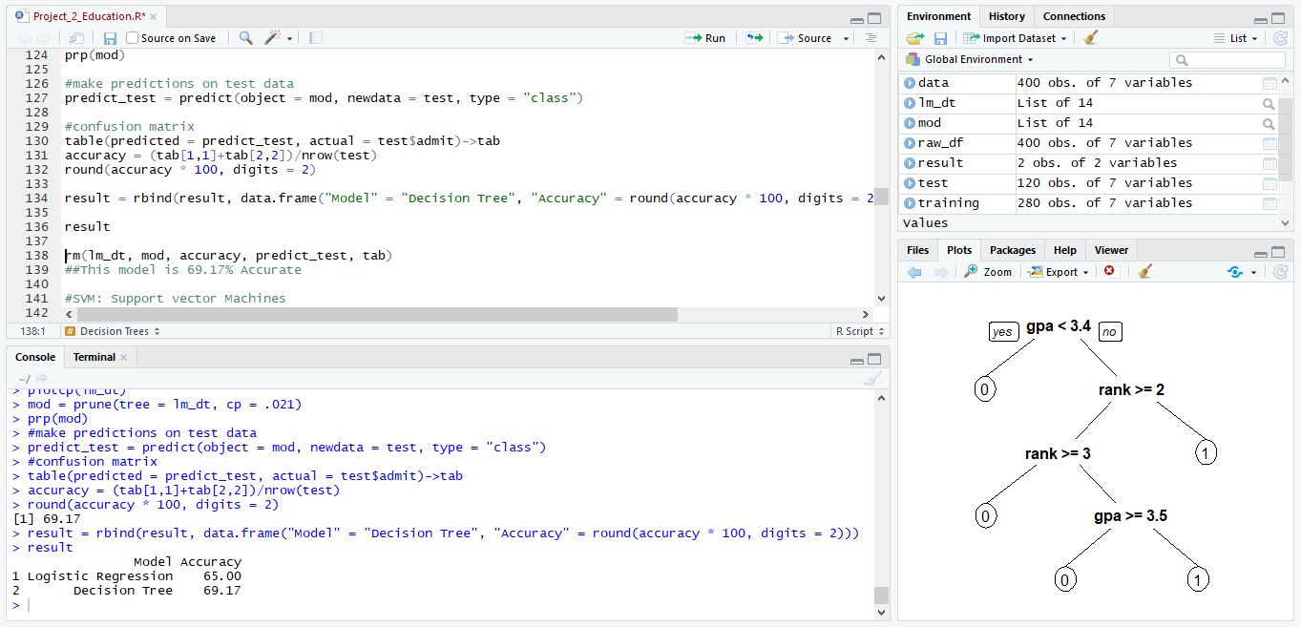

SVM: Support vector Machines

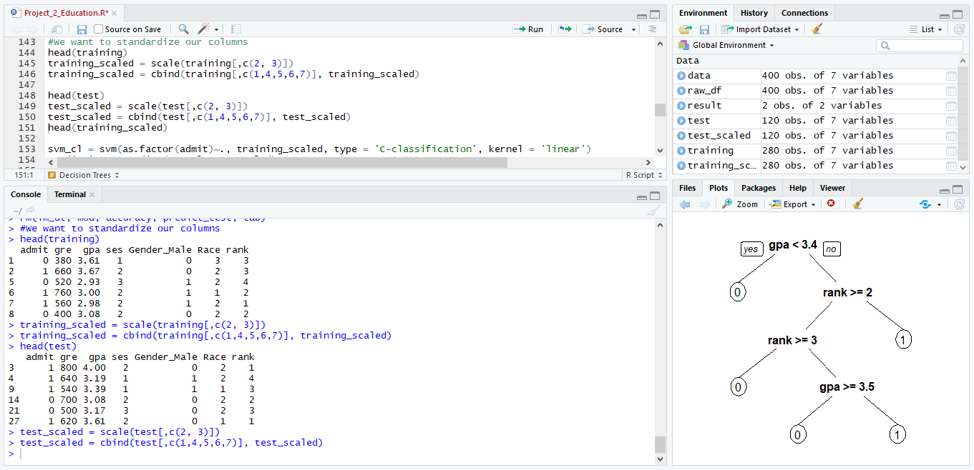

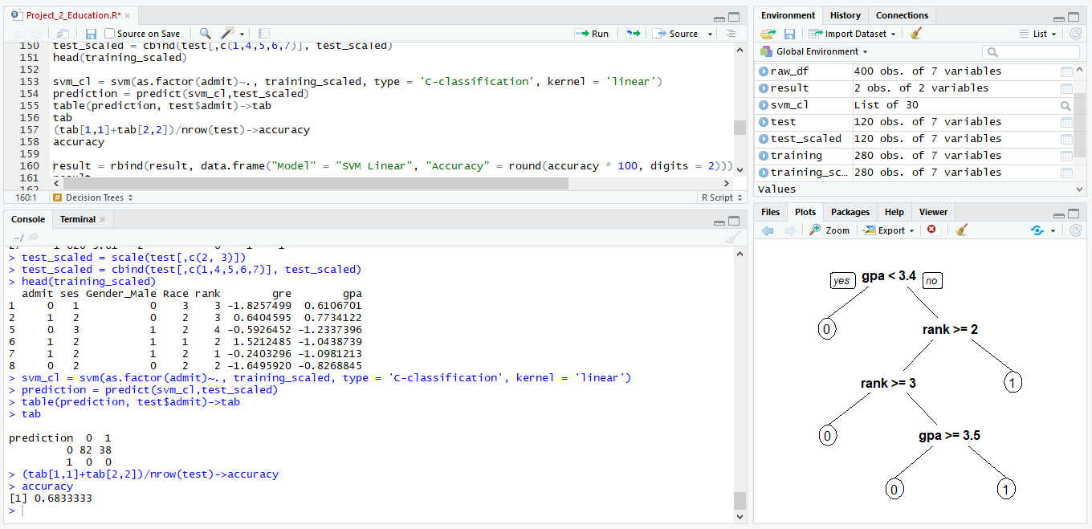

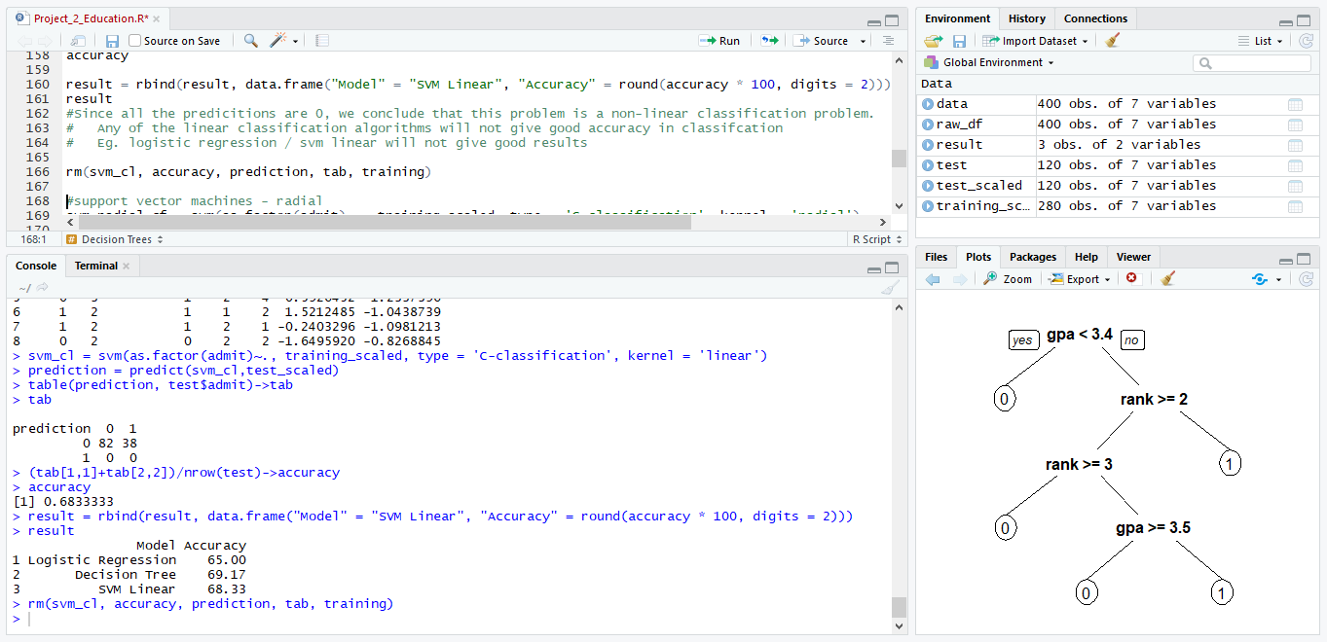

support vector machines – radial

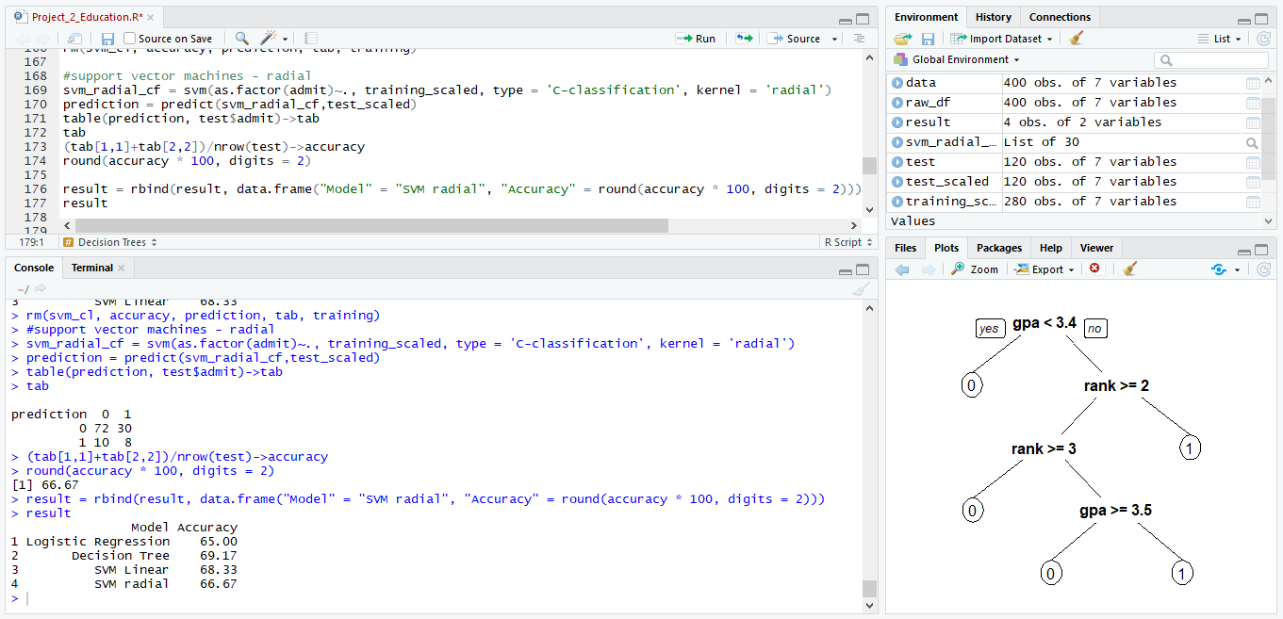

Random Forest

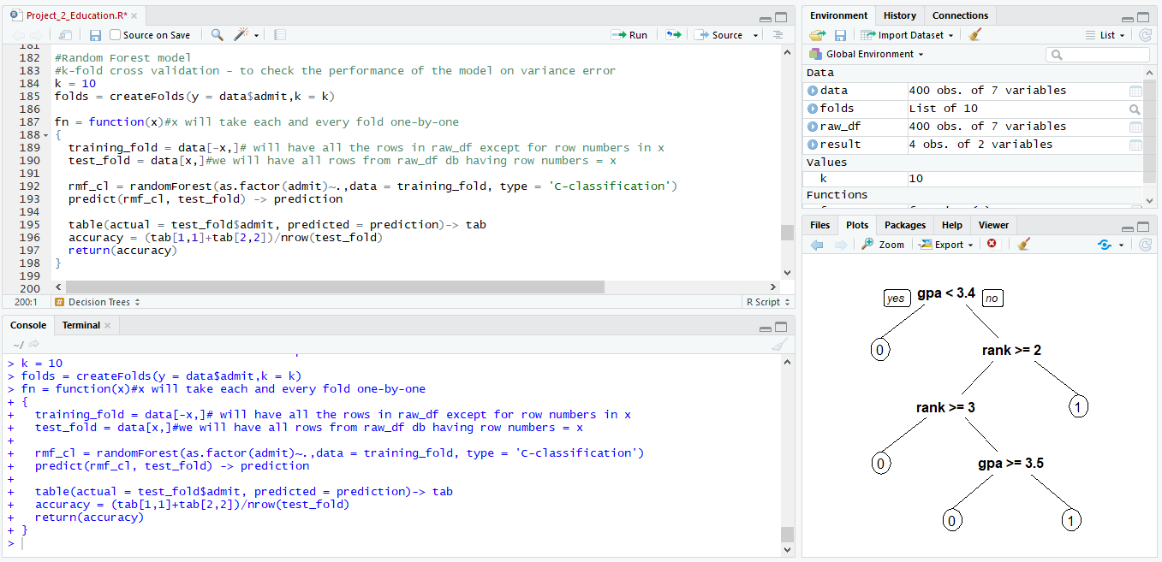

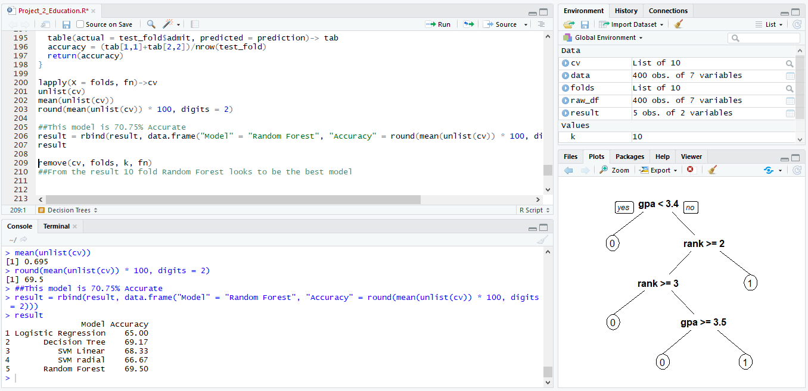

## Question 4

Categorize the grade point average into High, Medium, and Low (with admission probability percentages) and plot it on a point chart.

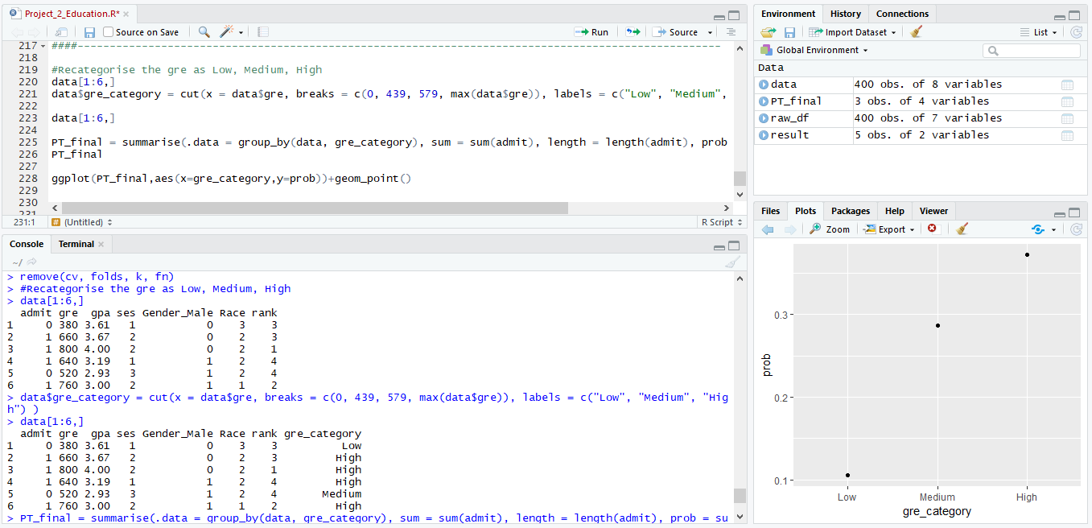

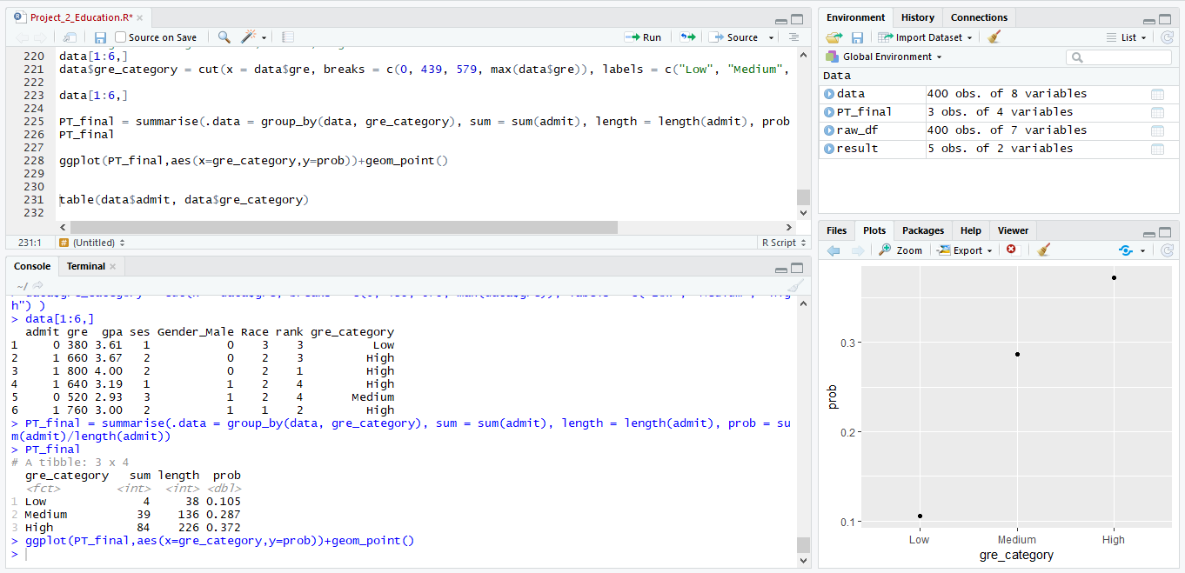

## Complete source code :



## Complete console output :

